**Application in Real Life Scenario Case Study**

**Description**:

The scenario focuses on the use of data analytics in the transportation to optimize route planning and reduce travel time for passengers to travel across different places.



**Planning:**

It is the basic step of gathering the requirements in data analytics. It defines the goal of the objective to reduce the time taken by the passenger in the transportation industry



**Prepare:**

In this step, we gather relevant data from various sources, such as GPS tracking, traffic patterns, and public transportation schedules.

**Process:**

Process transform the data into a usable format. Which includes the execution and implementation of the routes and accessible roads that reduces the travel time

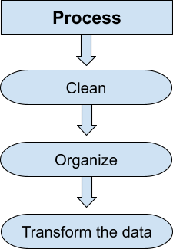

**Key Elements:**

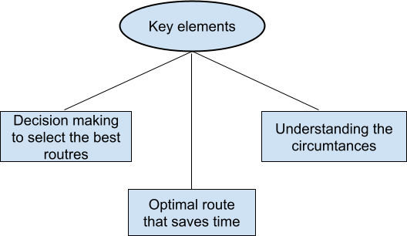

**Analysis:**

We have to choose that route which requires less time to reach the destination . It may depends on the Traffic , the time it requires to reach the destination , optimal travel times and based on some other circumstances.

**Share:**

To identify the best routes which takes the optimal time than the required time to reach the destination

**Act:**

Implement the suggested improvements, like adjusting routes and schedules based on insights.

You finally choose that route after the analysis which required less time to reach the different places.